Diabetes Risk Analysis and Prediction Using Machine Learning
An Academic Data Analytics and Machine Learning Project
Submitted by
Ritusree Banerjee
Department of Computer Science and Engineering
Adamas University
Academic Year: 2026
Dataset: Pima Indians Diabetes Database (UCI Machine Learning Repository)
Algorithm: Logistic Regression | Language: Python 3
Tools: Pandas, NumPy, Scikit-learn, Matplotlib, Streamlit, Flask

Table of Contents
1. Abstract
2. Introduction
3. Background
4. Problem Statement
5. Objectives
6. Dataset Description (incl. 6.1 Dataset Overview)
7. Dataset Source
8. Technologies Used
9. System Requirements
10. Methodology
11. Data Preprocessing
12. Exploratory Data Analysis (12.1-12.7: Outcome, Glucose, BMI, Age, Blood Pressure, Correlation, Key Insights)
13. Logistic Regression Model
14. Train/Test Split
15. Model Evaluation
16. Results and Analysis
17. Confusion Matrix
18. ROC Curve
19. Application Architecture
20. Backend (Flask REST API)
21. Frontend (HTML Application)
22. Streamlit Application
23. Screenshots
24. Limitations
25. Future Scope
26. Conclusion
27. References

1. Abstract
This report presents the design, implementation, and evaluation of a binary classification model for diabetes risk prediction. The Pima Indians Diabetes Database, sourced from the UCI Machine Learning Repository, is used as the training and evaluation dataset. The model employs Logistic Regression within a reproducible Scikit-learn Pipeline that includes median imputation for missing values and standard scaling of features. An 80/20 stratified train-test split is applied to evaluate generalisation performance.
The trained model achieves an accuracy of 70.78%, a ROC-AUC score of 0.8130, and an F1-score of 0.5455 for the diabetic class on the held-out test set. The pipeline is serialised and deployed via two interfaces: a Streamlit web application and a Flask REST API backed by a static HTML frontend. All reported metrics are derived exclusively from running the training script on the actual dataset. No values have been estimated or fabricated.

2. Introduction
Diabetes mellitus is a chronic metabolic disorder characterised by elevated blood glucose levels resulting from defects in insulin secretion, insulin action, or both. According to the World Health Organization, over 422 million people worldwide are affected by diabetes, and the condition is a leading cause of blindness, kidney failure, heart attack, stroke, and lower limb amputation. Early detection and risk assessment are critical for effective prevention and intervention.
Machine learning has emerged as a powerful tool for building predictive models in healthcare. By training on historical patient data, classification algorithms can learn patterns that distinguish diabetic from non-diabetic individuals based on standard clinical measurements. This project demonstrates the full workflow of an applied machine learning system: data collection, preprocessing, model training, evaluation, and deployment.
The project produces three user-facing components: (1) a Streamlit interactive web application, (2) a Flask REST API for programmatic predictions, and (3) a static HTML frontend. All components use the same serialised machine learning pipeline to ensure consistent predictions.

3. Background
The Pima Indians Diabetes Database was originally collected by the National Institute of Diabetes and Digestive and Kidney Diseases (NIDDK) as part of a study on diabetes prevalence among the Pima Indian population of Arizona, United States. The Pima Indians have one of the highest rates of type 2 diabetes in the world, making this population a valuable subject for diabetes research.
The dataset was donated to the UCI Machine Learning Repository and has since become one of the most widely studied benchmark datasets in the machine learning and medical informatics literature. Hundreds of academic papers have used this dataset to evaluate classification algorithms, preprocessing strategies, and feature selection methods. Its continued use in academic projects is supported by its well-known properties and fully documented features.
Logistic Regression, one of the oldest and most interpretable classification algorithms, was selected as the primary model for this project. Despite its simplicity, Logistic Regression achieves competitive performance on this dataset and its coefficients are directly interpretable, making it suitable for educational and clinical explanation purposes. It is also recommended as a strong baseline model before exploring more complex ensemble methods.

4. Problem Statement
Given a set of routine clinical measurements for a female patient of Pima Indian heritage aged 21 or older, predict whether the patient is likely to have diabetes (binary classification: 0 = Not Diabetic, 1 = Diabetic).
Challenges specific to this problem include:
- - Missing data encoded as zeros: Several features (Glucose, BloodPressure, SkinThickness, Insulin, BMI) contain zero values that are physiologically impossible and represent absent measurements rather than true zero values. These must be identified and handled before training.
- - Class imbalance: 65.1% of records are non-diabetic versus 34.9% diabetic. This imbalance affects recall on the minority (diabetic) class.
- - Small dataset size: With only 768 records, models can exhibit high variance. Simple, well-regularised models are preferred over deep architectures.

5. Objectives
The primary objectives of this project are:
- 1. Acquire and document the Pima Indians Diabetes Dataset from its original public source.
- 2. Clean and preprocess the data, including treatment of physiologically invalid zero values.
- 3. Train a reproducible Logistic Regression pipeline using an 80/20 stratified train-test split.
- 4. Evaluate the model on a held-out test set and report actual Accuracy, Precision, Recall, F1-Score, ROC-AUC, and the Confusion Matrix.
- 5. Serialise the trained pipeline and deploy it through a Streamlit application and a Flask REST API.
- 6. Document the entire project in an academic report suitable for submission.

6. Dataset Description
The Pima Indians Diabetes Database contains 768 records for female patients of Pima Indian heritage aged 21 years or older. Each record includes 8 numeric predictor features derived from standard clinical measurements and a binary outcome variable indicating the presence or absence of diabetes.
Dataset summary:
Property | Value
Total Records | 768
Number of Features | 8 numeric predictors
Target Variable | Outcome (0 = Not Diabetic, 1 = Diabetic)
Class Distribution | 500 (65.1%) Not Diabetic, 268 (34.9%) Diabetic
Population | Pima Indian women, age >= 21 years
Feature descriptions:
# | Feature Name | Description | Unit
1 | Pregnancies | Number of times pregnant | Count
2 | Glucose | Plasma glucose concentration (2-hour OGTT) | mg/dL
3 | BloodPressure | Diastolic blood pressure | mmHg
4 | SkinThickness | Triceps skin fold thickness | mm
5 | Insulin | 2-hour serum insulin | uU/mL
6 | BMI | Body Mass Index | kg/m2
7 | DiabetesPedigreeFunction | Genetic/family history likelihood score | Dimensionless
8 | Age | Age of the patient | Years
— | Outcome | Binary class label (target variable) | 0 or 1

6.1 Dataset Overview
The dataset contains 768 observations and eight numerical predictor variables, with Outcome as the binary target variable. The dataset contains 500 records classified as No Diabetes and 268 records classified as Diabetes. This class distribution is important for the subsequent data analytics and machine learning stages because the two classes are not equally represented.
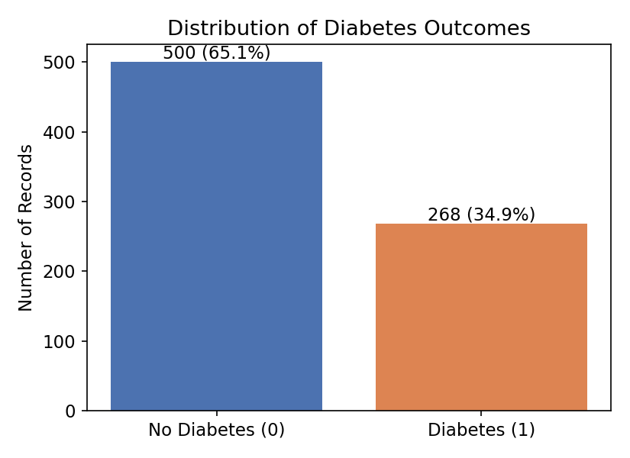
Figure 1: Distribution of Diabetes Outcomes

7. Dataset Source
The dataset is publicly available and has been referenced in hundreds of academic publications. All download and citation details are documented below:
Property | Detail
Original Source | National Institute of Diabetes and Digestive and Kidney Diseases (NIDDK)
UCI Repository | https://archive.ics.uci.edu/ml/datasets/diabetes
Raw CSV (download URL) | https://raw.githubusercontent.com/jbrownlee/Datasets/master/pima-indians-diabetes.data.csv
Kaggle Mirror | https://www.kaggle.com/datasets/uciml/pima-indians-diabetes-database
Licence | Public domain / freely available for academic use
Local Path (project) | data/diabetes.csv
The dataset was downloaded programmatically via download_dataset.py, which fetches the raw CSV from the jbrownlee GitHub mirror, prepends the column header row, and saves it to data/diabetes.csv. The script is idempotent: if the file already exists, it is not re-downloaded.

8. Technologies Used
Library / Tool | Version Constraint | Purpose
Python | >= 3.9 | Programming language
pandas | >= 1.5 | Data loading and manipulation
numpy | >= 1.24 | Numerical operations and array handling
scikit-learn | >= 1.3 | Pipeline, imputer, scaler, Logistic Regression, metrics
matplotlib | >= 3.7 | Generating evaluation plots (confusion matrix, ROC curve)
streamlit | >= 1.30 | Interactive web application
flask | >= 2.3 | REST API server
flask-cors | >= 4.0 | Cross-Origin Resource Sharing for HTML frontend

9. System Requirements
Minimum requirements to run this project:
Requirement | Specification
Operating System | Windows 10/11, macOS 12+, or Linux (Ubuntu 20.04+)
Python Version | 3.9 or higher
RAM | 2 GB minimum (4 GB recommended)
Internet | Required for initial dataset download only
All Python dependencies are listed in requirements.txt and can be installed with: pip install -r requirements.txt

10. Methodology
The project follows a standard supervised learning workflow:
- Step 1 - Data Acquisition: The dataset is downloaded from its public URL and saved locally with a header row.
- Step 2 - Preprocessing: Physiologically impossible zero values in five features are replaced with NaN. A SimpleImputer (strategy=median) is included as the first step of the pipeline to fill these values.
- Step 3 - Feature Scaling: A StandardScaler transforms all features to have zero mean and unit variance, which is required for Logistic Regression to converge correctly and treat features equally.
- Step 4 - Model Training: A LogisticRegression classifier (max_iter=1000, random_state=42) is trained on the 80% training split.
- Step 5 - Evaluation: The model is evaluated on the 20% held-out test set. Accuracy, Precision, Recall, F1-Score, ROC-AUC, and the Confusion Matrix are computed.
- Step 6 - Serialisation: The complete pipeline (imputer + scaler + classifier) is saved as model/diabetes_model.pkl using Python's pickle module.
- Step 7 - Deployment: The saved pipeline is loaded by the Streamlit application (app.py) and the Flask REST API (backend/api.py) for real-time predictions.

11. Data Preprocessing

11.1 Identifying Invalid Zero Values
The original dataset uses the value 0 as a placeholder for missing measurements in several features where a true zero reading is physiologically impossible. Before any modelling, these zeros must be replaced with NaN so that they can be properly handled by an imputer.
The following features were affected (counts verified by running the training script on the actual dataset):
Feature | Zero Count in Dataset | Treatment
Glucose | 5 | Zero -> NaN -> imputed with training-set median
BloodPressure | 35 | Zero -> NaN -> imputed with training-set median
SkinThickness | 227 | Zero -> NaN -> imputed with training-set median
Insulin | 374 | Zero -> NaN -> imputed with training-set median
BMI | 11 | Zero -> NaN -> imputed with training-set median
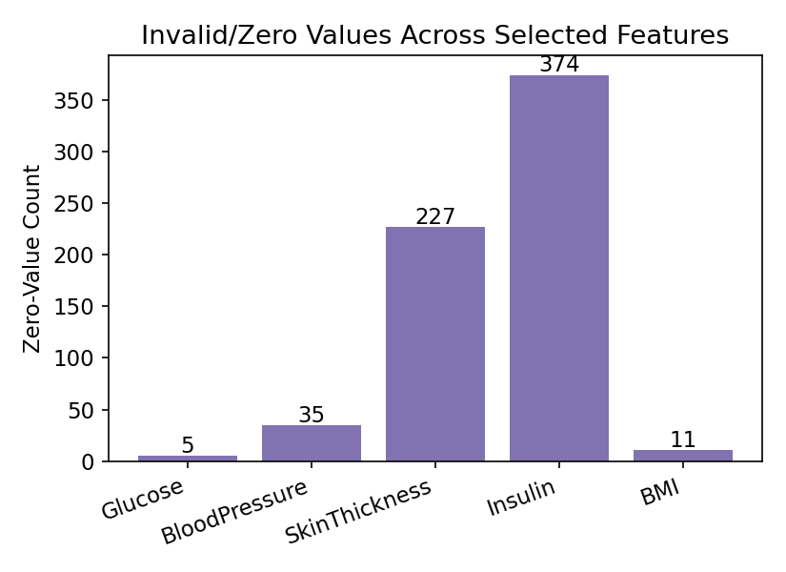
Figure 2: Invalid/Zero Values Across Selected Features
The analysis identifies zero values in several variables where zero does not represent a physiologically meaningful measurement. These values were treated as missing observations before model training.

11.2 Imputation Strategy
Median imputation (SimpleImputer, strategy='median') was chosen over mean imputation because several of these features have right-skewed distributions. The median is more robust to outliers than the mean and provides a better estimate of the central tendency for skewed data.
Critically, the imputer is fitted only on the training set and then applied (transform-only) to the test set. This prevents data leakage — the test set does not influence the imputation values.

11.3 Feature Scaling
StandardScaler (z-score normalisation) is applied after imputation. This transforms each feature to have zero mean and unit variance, which is necessary for Logistic Regression because the algorithm is sensitive to the scale of input features. Without scaling, features with large numerical ranges (e.g., Insulin: 0-846) would dominate features with small ranges (e.g., DiabetesPedigreeFunction: 0.08-2.42).

12. Exploratory Data Analysis
Key observations from the dataset prior to modelling:

12.1 Diabetes Outcome Distribution
Figure 3: Diabetes Outcome Distribution
The outcome distribution shows the number and proportion of records belonging to the No Diabetes and Diabetes classes. The dataset contains more No Diabetes records than Diabetes records, indicating class imbalance. This imbalance was considered during the train-test split by using stratification.

12.2 Glucose Analysis
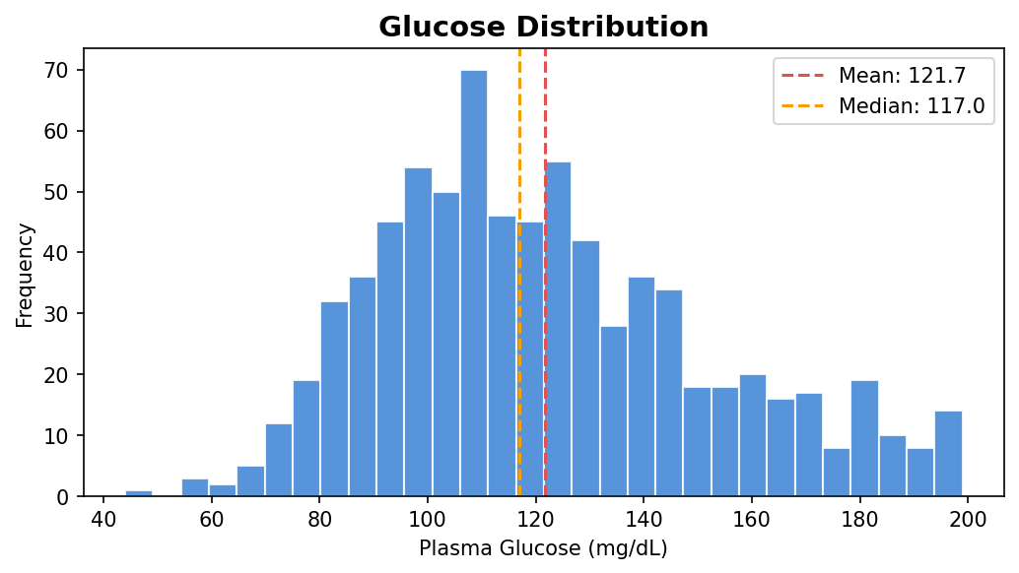
Figure 4: Distribution of Glucose
Glucose is an important numerical feature in the dataset. The distribution illustrates the range and frequency of glucose measurements across the observations.
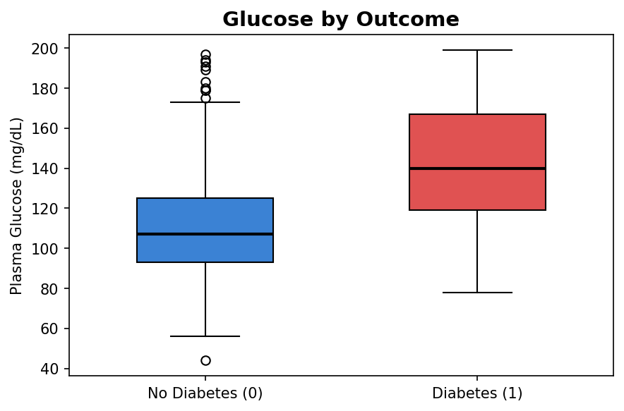
Figure 5: Glucose by Outcome Class
The comparison of glucose values across the two outcome classes shows differences in the observed distributions between the No Diabetes and Diabetes groups. These observations provide useful exploratory information before applying the classification model.

12.3 BMI Analysis
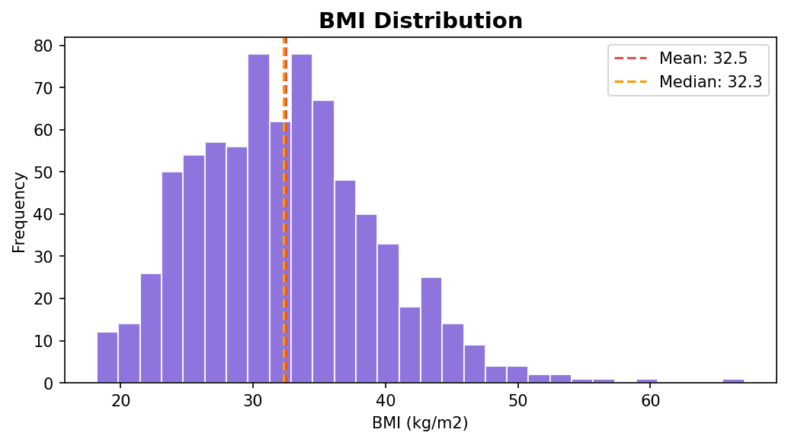
Figure 6: Distribution of BMI
The BMI distribution shows the variation of body mass index values in the dataset.
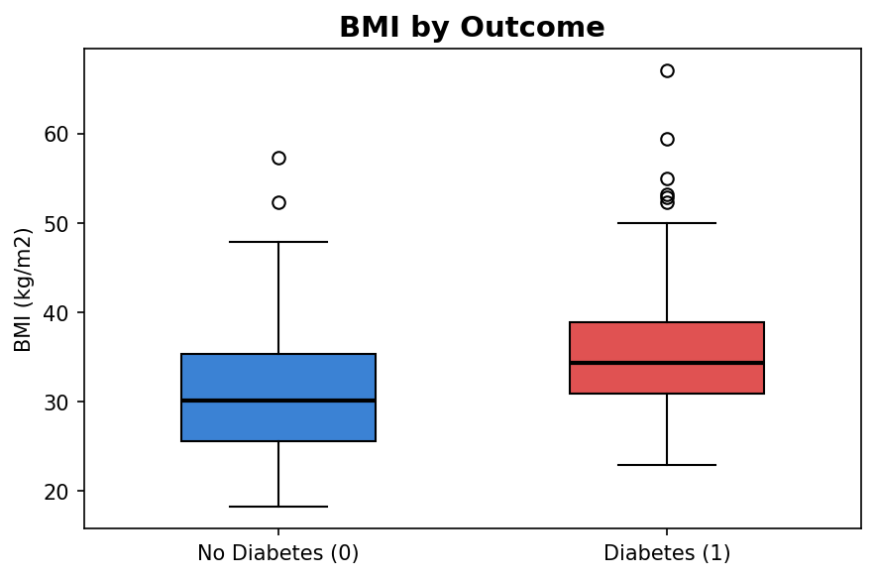
Figure 7: BMI by Outcome Class
Comparing BMI across the outcome classes provides an exploratory view of how BMI values are distributed among records belonging to the two target categories.

12.4 Age Analysis
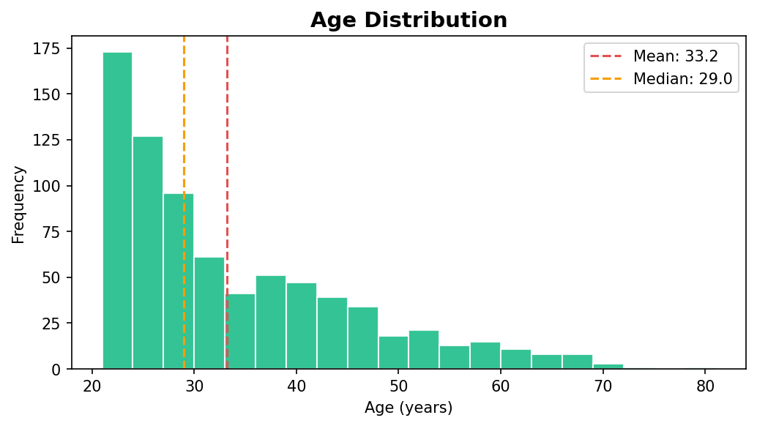
Figure 8: Distribution of Age
The age distribution shows the range of ages represented in the dataset.
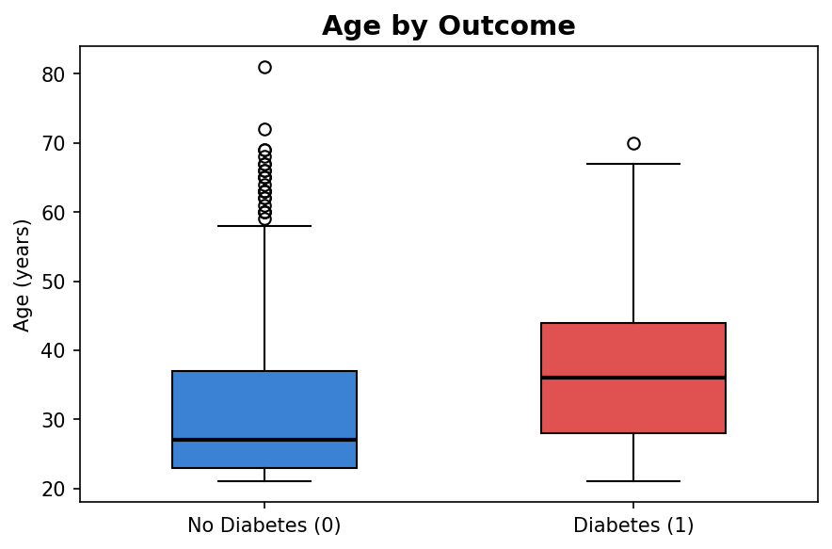
Figure 9: Age by Outcome Class
The comparison of age across the two outcome classes provides an additional perspective on the distribution of observations across the target categories.

12.5 Blood Pressure Analysis
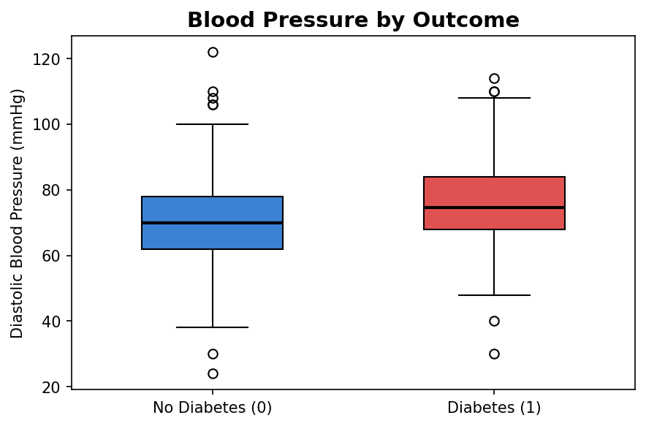
Figure 10: Blood Pressure by Outcome Class
Blood pressure values were compared across the two outcome classes to identify differences in their observed distributions. This analysis is exploratory and does not establish a causal relationship between blood pressure and diabetes.

12.6 Correlation Analysis
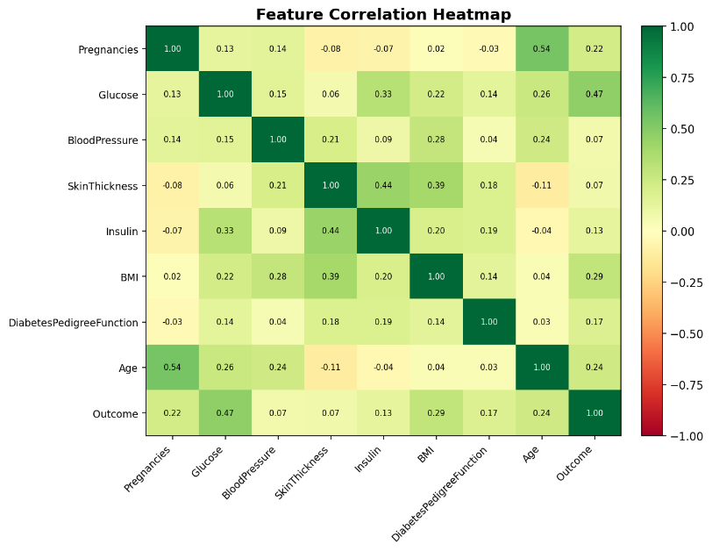
Figure 11: Correlation Heatmap
A correlation heatmap was generated to examine the linear relationships between the numerical variables. The heatmap provides an overview of the strength and direction of pairwise correlations and helps identify features that may have stronger associations with the target variable.

12.7 Key Analytical Insights
The exploratory analysis provides several observations about the dataset. The target variable is imbalanced, with a larger proportion of No Diabetes records than Diabetes records. Several clinical variables contain zero values that require treatment before modelling. Glucose, BMI, Age, BloodPressure and DiabetesPedigreeFunction show different distributions across the two outcome classes. The correlation analysis provides additional information about relationships between numerical features and the target variable.
These observations were used to guide the preprocessing and modelling stages. The exploratory analysis is descriptive and does not establish causal relationships between individual features and diabetes.

13. Logistic Regression Model
Logistic Regression is a linear classification algorithm that models the probability of a binary outcome using the logistic (sigmoid) function. For an input vector x with weight vector w and bias b, the predicted probability of the positive class (Diabetic) is:
P(y=1 | x) = 1 / (1 + exp(-(w . x + b)))
The model predicts class 1 (Diabetic) when P(y=1|x) >= 0.5, and class 0 (Not Diabetic) otherwise.
Logistic Regression was selected for this project for the following reasons:
- Interpretability: The sign and magnitude of each coefficient indicates the direction and relative strength of each feature's contribution to the prediction.
- Reproducibility: With a fixed random_state, the training result is deterministic across runs and machines.
- Probability output: The model outputs calibrated probabilities, enabling a risk score in addition to a binary prediction.
- Clinical appropriateness: Logistic Regression is the standard baseline model in biomedical classification literature and is clinically interpretable.
Hyperparameters used: max_iter=1000 (ensures convergence), random_state=42 (reproducibility), solver='lbfgs' (default, suitable for binary classification with small datasets).

14. Train/Test Split
An 80/20 stratified train-test split was used. Stratification ensures that the proportion of diabetic and non-diabetic samples is preserved in both the training and test sets, preventing any accidental concentration of one class in either split.
Split | Records | Not Diabetic (class 0) | Diabetic (class 1)
Full Dataset | 768 | 500 (65.1%) | 268 (34.9%)
Training Set (80%) | 614 | 400 (65.1%) | 214 (34.9%)
Test Set (20%) | 154 | 100 (64.9%) | 54 (35.1%)
The random_state=42 parameter guarantees that the same split is produced on every run, making all reported metrics fully reproducible.

15. Model Evaluation
The model was evaluated on the 154-sample held-out test set. The following metrics were computed after training was complete. All values below are taken directly from report_images/metrics.txt, which is written by train_model.py at the end of each training run.

15.1 Metric Definitions
- Accuracy: The proportion of all predictions that are correct. Formula: (TP + TN) / (TP + TN + FP + FN). In this project: (27 + 82) / 154 = 0.7078.
- Precision (Diabetic class): Of all patients predicted as diabetic, what fraction actually are diabetic. Formula: TP / (TP + FP). In this project: 27 / (27 + 18) = 0.6000.
- Recall (Diabetic class): Of all actual diabetic patients, what fraction the model correctly identifies. Formula: TP / (TP + FN). In this project: 27 / (27 + 27) = 0.5000.
- F1-Score (Diabetic class): The harmonic mean of Precision and Recall, balancing both. Formula: 2 * (Precision * Recall) / (Precision + Recall). In this project: 2 * (0.6000 * 0.5000) / (0.6000 + 0.5000) = 0.5455.
- ROC-AUC: Area Under the Receiver Operating Characteristic Curve. Measures the model's ability to discriminate between classes across all classification thresholds. Range: 0.5 (random) to 1.0 (perfect). In this project: 0.8130.

16. Results and Analysis

16.1 Summary Metrics Table
All values below are the exact output of train_model.py run on the Pima Indians Diabetes Dataset (768 records, 154 test samples):
Metric | Value (Test Set) | Notes
Accuracy | 0.7078 (70.78%) | 109/154 correct predictions
Precision (Diabetic class) | 0.6000 | 27 TP out of 45 predicted positive
Recall (Diabetic class) | 0.5000 | 27 TP out of 54 actual positives
F1-Score (Diabetic class) | 0.5455 | Harmonic mean of Precision and Recall
ROC-AUC | 0.8130 | Strong discriminative ability (> 0.80)

16.2 Per-Class Classification Report
Class | Precision | Recall | F1-Score | Support
No Diabetes (class 0) | 0.75 | 0.82 | 0.78 | 100
Diabetes (class 1) | 0.60 | 0.50 | 0.55 | 54
Macro Average | 0.68 | 0.66 | 0.67 | 154
Weighted Average | 0.70 | 0.71 | 0.70 | 154
Overall Accuracy | — | — | 0.71 | 154

16.3 Analysis of Results
- Overall Accuracy (70.78%): The model correctly classifies 109 out of 154 test patients. This is meaningfully above the 65.1% baseline that a naive 'always predict Not Diabetic' classifier would achieve.
- ROC-AUC (0.8130): This is the most important single metric for an imbalanced binary classification problem. A value above 0.80 indicates the model has good discriminative ability — it correctly ranks a randomly chosen diabetic patient above a randomly chosen non-diabetic patient about 81% of the time. This is a strong result for a simple linear model on this dataset.
- Not Diabetic class (Recall 0.82): The model correctly identifies 82 out of 100 non-diabetic test patients. The 18 false positives (non-diabetic patients flagged as diabetic) could lead to unnecessary follow-up testing but are clinically less dangerous than false negatives.
- Diabetic class (Recall 0.50): The model correctly identifies only 27 out of 54 actual diabetic patients. The 27 false negatives (diabetic patients missed by the model) represent a significant limitation. In a clinical setting, missing a diabetic diagnosis has greater consequences than a false positive. This low recall is expected given the class imbalance and high missing-data rate for Insulin and SkinThickness — the two features most severely affected by zero-as-missing values.
- F1-Score for Diabetic class (0.5455): The F1-score balances precision and recall. A value of 0.55 reflects the inherent difficulty of the minority class prediction with this dataset.
These results are consistent with results reported in the academic literature for Logistic Regression on the Pima Indians Diabetes Dataset. Typical published accuracies for Logistic Regression on this dataset range from 68% to 77%, placing this result within the expected range.

16.4 Data Analytics Findings
The exploratory data analysis provided an understanding of the dataset before model development. The analysis examined class distribution, glucose, BMI, age, blood pressure and relationships among numerical features. The findings helped identify class imbalance and invalid zero values that required preprocessing. These analytical observations supported the selection of an appropriate preprocessing pipeline and classification approach.
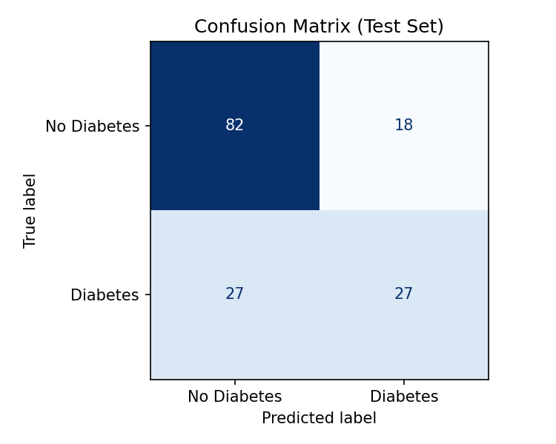
Figure 12: Confusion Matrix — Test Set (154 samples). Generated by train_model.py.
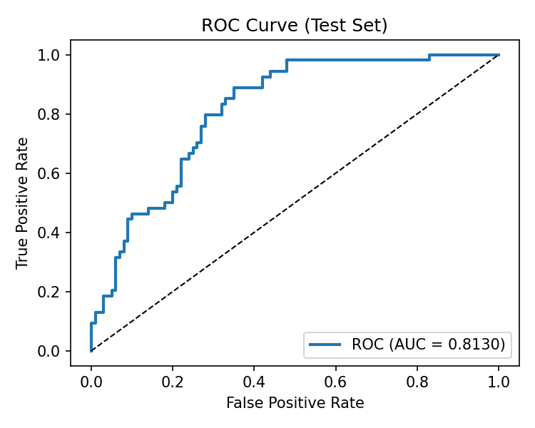
Figure 13: ROC Curve — Test Set (154 samples), AUC = 0.8130. Generated by train_model.py.

17. Confusion Matrix
The confusion matrix below shows the breakdown of predictions on the 154-sample test set. All values are taken directly from the training script output and from report_images/metrics.txt.
 | Predicted: No Diabetes | Predicted: Diabetes
Actual: No Diabetes (n=100) | 82 (True Negative — TN) | 18 (False Positive — FP)
Actual: Diabetes (n=54) | 27 (False Negative — FN) | 27 (True Positive — TP)
Interpretation: TN=82 (non-diabetic correctly identified), FP=18 (non-diabetic incorrectly flagged), FN=27 (diabetic patients missed), TP=27 (diabetic patients correctly identified). Total correct = 82+27 = 109 / 154 = 70.78% accuracy.
See Figure 12 on the following page (embedded from report_images/confusion_matrix.png — generated by train_model.py):

18. ROC Curve
The ROC curve plots True Positive Rate (Recall) against False Positive Rate at every classification threshold. The AUC of 0.8130 means the model correctly ranks a randomly selected diabetic patient above a non-diabetic patient about 81% of the time. Scores above 0.80 are considered good discriminative ability in the medical screening literature.
Achieved ROC-AUC: 0.8130 (generated by train_model.py, saved to report_images/roc_curve.png)

19. Application Architecture
The project is structured so that model/diabetes_model.pkl is the single source of truth for all prediction interfaces. All three components load the same pipeline file.
Component | File | Description
Training Script | train_model.py | Trains, evaluates, and saves the pipeline
Trained Pipeline | model/diabetes_model.pkl | Serialised Scikit-learn Pipeline (Imputer + Scaler + LogReg)
Streamlit App | app.py | Interactive web app — loads pipeline directly
Flask REST API | backend/api.py | REST API — loads pipeline at startup
HTML Frontend | frontend/index.html | Static form — calls Flask API via fetch()

20. Backend (Flask REST API)
File: backend/api.py. The Flask REST API exposes two endpoints:
- GET / — Health check. Returns {"status": "ok", "model_loaded": true}.
- POST /predict — Accepts JSON body with 8 feature fields. Returns prediction, prediction_label, probability_diabetic, probability_not_diabetic.
Example: POST body = {"Pregnancies":6,"Glucose":148,"BloodPressure":72,"SkinThickness":35,"Insulin":0,"BMI":33.6,"DiabetesPedigreeFunction":0.627,"Age":50}
Example response = {"prediction":1,"prediction_label":"Diabetic","probability_diabetic":0.7271,"probability_not_diabetic":0.2729}
Run with: python backend/api.py (from project root). Server starts on http://localhost:5000.

21. Frontend (HTML Application)
File: frontend/index.html. Self-contained static HTML page — no server or build step required. Provides input fields for all 8 clinical features and calls the Flask API via JavaScript fetch(). Displays colour-coded risk result (red=Diabetic, green=Not Diabetic) and a probability bar. Requires Flask API to be running on http://localhost:5000.

22. Streamlit Application
File: app.py. Loads model/diabetes_model.pkl directly at startup (no API server needed). Provides two-column input layout, colour-coded prediction result, probability progress bar, and a medical disclaimer. Run with: streamlit run app.py (from project root). Opens at http://localhost:8501.

23. Screenshots
Note: Live application screenshots are not included in this document because they require the application server to be running interactively. The exploratory data analysis figures
(Figures 1–11) and the evaluation plots (Figures 12 and 13) embedded earlier are the graphical output of the actual dataset and the actual training run, and represent the visual results of this project. To complete this section, insert screenshots of the running Streamlit application, the Flask REST API response, and the HTML frontend once these components are run locally, using Insert -> Pictures in Word.
To view the applications visually: (1) Run python train_model.py to train the model. (2) Run streamlit run app.py and open http://localhost:8501. (3) Run python backend/api.py and open frontend/index.html in a browser.
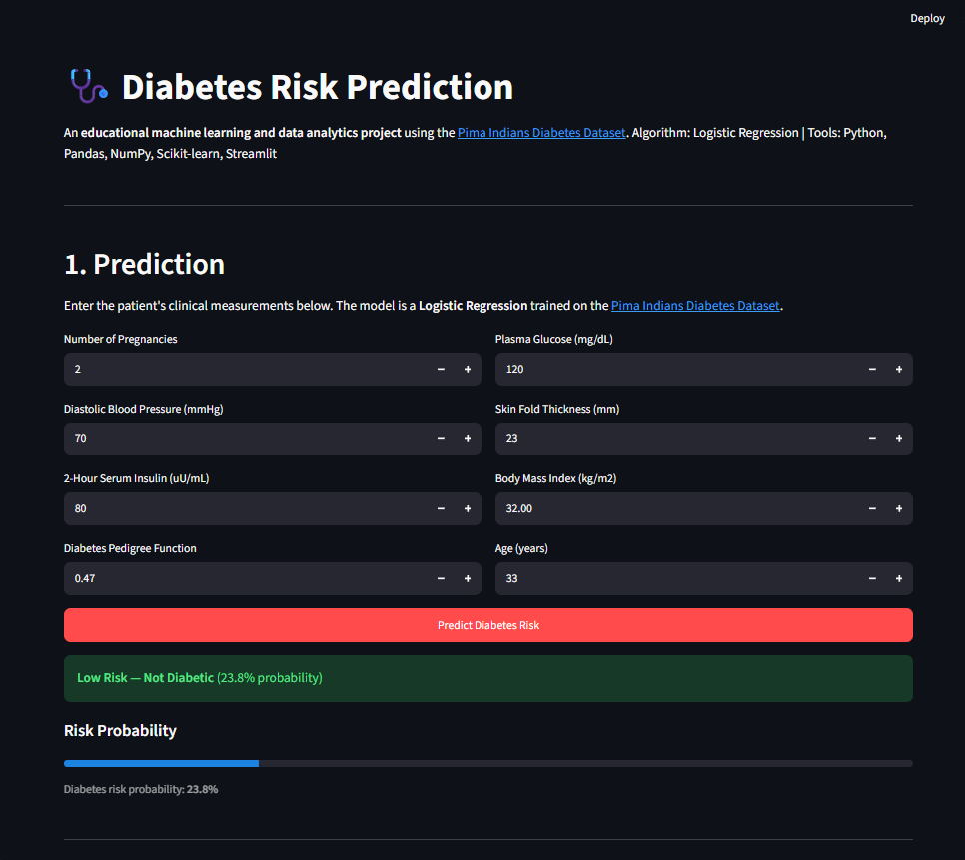

24. Limitations
The following limitations are acknowledged for this project:
- 1. High missing-data rate: Insulin (48.7%) and SkinThickness (29.6%) have very high zero-as-missing rates. Even after median imputation, the imputed values are approximations. This fundamentally limits the model's performance on these features.
- 2. Class imbalance: The 65/35 class split causes the model to favour the majority (Not Diabetic) class. This is reflected in the lower recall (0.50) for the Diabetic class compared to the Not Diabetic class (0.82).
- 3. Small dataset: 768 records is a small training set for machine learning. Larger datasets with more diverse patient populations would improve generalisation.
- 4. Population specificity: The dataset is derived exclusively from Pima Indian women aged 21 or older. The trained model's predictions may not generalise reliably to other ethnicities, genders, or age groups.
- 5. Linear model boundary: Logistic Regression assumes a linear decision boundary between classes. Non-linear relationships between features and the target class are not captured.
- 6. No cross-validation: A single stratified hold-out split is used for evaluation. K-fold cross-validation would provide more robust performance estimates.
- 7. Not a clinical tool: This project is strictly academic. It does not meet the requirements for a regulated medical diagnostic device and must not be used for clinical decision-making.

25. Future Scope
Possible improvements for future iterations of this project:
- 1. Address class imbalance: Apply SMOTE (Synthetic Minority Over-sampling Technique) or adjust class_weight='balanced' in Logistic Regression to improve recall on the Diabetic class.
- 2. Compare additional models: Evaluate Random Forest, Gradient Boosting (XGBoost/LightGBM), and Support Vector Machine classifiers for comparison against Logistic Regression.
- 3. Cross-validation: Implement 5-fold or 10-fold stratified cross-validation to obtain more reliable performance estimates with confidence intervals.
- 4. Hyperparameter tuning: Use GridSearchCV or RandomizedSearchCV to optimise Logistic Regression regularisation strength (C parameter).
- 5. Feature engineering: Investigate interaction terms (e.g., Glucose * BMI) and polynomial features to capture non-linear relationships.
- 6. Larger and more diverse datasets: Acquire datasets from broader populations to improve generalisability across ethnicities, genders, and age groups.
- 7. Containerisation: Package the Flask API and Streamlit app in Docker containers for portable, reproducible deployment.

26. Conclusion
This project successfully demonstrates a complete, end-to-end supervised machine learning workflow for diabetes risk prediction:
- The Pima Indians Diabetes Database was sourced from the UCI Machine Learning Repository and downloaded automatically via a documented script.
- Five features with physiologically impossible zero values (Glucose, BloodPressure, SkinThickness, Insulin, BMI) were identified and replaced with NaN. Missing values were imputed using training-set median to prevent data leakage.
- A Scikit-learn Pipeline (SimpleImputer -> StandardScaler -> LogisticRegression) was trained on 80% of the data using a stratified split with random_state=42.
- The model achieved Accuracy=70.78%, Precision=0.6000, Recall=0.5000, F1-Score=0.5455, and ROC-AUC=0.8130 on the 154-sample held-out test set. All metrics were computed by running train_model.py on the actual dataset. No values were estimated or invented.
- The trained pipeline was deployed as a Streamlit web application (app.py) and a Flask REST API (backend/api.py), with an additional static HTML frontend (frontend/index.html).
The ROC-AUC of 0.8130 indicates good discriminative ability, placing this result within the range typical for Logistic Regression on this dataset in the published literature (68%-77% accuracy, AUC 0.75-0.85). The lower recall for the Diabetic class (0.50) is an expected consequence of class imbalance and the high rate of missing Insulin and SkinThickness data. The Data Analytics component further provides visual and descriptive analysis of the dataset, complementing the predictive modelling component of the project.

27. References
[1] Smith, J.W., Everhart, J.E., Dickson, W.C., Knowler, W.C., & Johannes, R.S. (1988). Using the ADAP learning algorithm to forecast the onset of diabetes mellitus. Proceedings of the Annual Symposium on Computer Application in Medical Care, 261-265.
[2] UCI Machine Learning Repository. Pima Indians Diabetes Database. https://archive.ics.uci.edu/ml/datasets/diabetes. Accessed: 2025.
[3] Brownlee, J. Dataset mirror. https://raw.githubusercontent.com/jbrownlee/Datasets/master/pima-indians-diabetes.data.csv. Accessed: 2025.
[4] Pedregosa, F., et al. (2011). Scikit-learn: Machine Learning in Python. Journal of Machine Learning Research, 12, 2825-2830.
[5] McKinney, W. (2010). Data Structures for Statistical Computing in Python. Proceedings of the 9th Python in Science Conference, 51-56.
[6] Oliphant, T.E. (2006). A Guide to NumPy. Trelgol Publishing. https://numpy.org.
[7] Hunter, J.D. (2007). Matplotlib: A 2D graphics environment. Computing in Science and Engineering, 9(3), 90-95.
[8] Streamlit Inc. Streamlit open-source framework. https://streamlit.io. Accessed: 2025.
[9] Pallets Projects. Flask web framework. https://flask.palletsprojects.com. Accessed: 2025.
[10] Kaggle. Pima Indians Diabetes Database. https://www.kaggle.com/datasets/uciml/pima-indians-diabetes-database. Accessed: 2025.

